Given the root of a binary tree, determine if it is a *complete binary tree*.

In a [**complete binary tree**](http://en.wikipedia.org/wiki/Binary_tree#Types_of_binary_trees), every level, except possibly the last, is completely filled, and all nodes in the last level are as far left as possible. It can have between 1 and 2h nodes inclusive at the last level h.

**Example 1:**

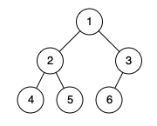

Input: root = [1,2,3,4,5,6]  
Output: true  
Explanation: Every level before the last is full (ie. levels with node-values {1} and {2, 3}), and all nodes in the last level ({4, 5, 6}) are as far left as possible.

**Example 2:**

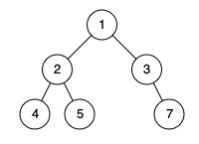

Input: root = [1,2,3,4,5,null,7]  
Output: false  
Explanation: The node with value 7 isn't as far left as possible.

**Constraints:**

* The number of nodes in the tree is in the range [1, 100].
* 1 <= Node.val <= 1000